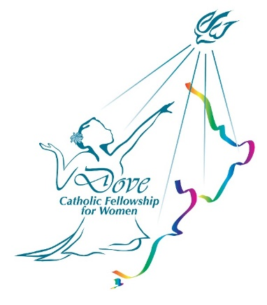

**18th SEPTEMBER**: **STEWARDS OF GOD’S GRACE**

Speaker: **Christine Kornman**

John 2: 1-5 On the third day there was a wedding in Cana of Galilee, and the mother of Jesus was there. Jesus and his disciples had also been invited to the wedding. When the wine gave out, the mother of Jesus said to him, “They have no wine.” And Jesus said to her, “Woman, what concern is that to you and to me? My hour has not yet come.” His mother said to the servants, “Do whatever he tells you.”

Held at ST. THOMAS MORE CHURCH HALL, 336 Wairau Road, GLENFIELD.

For more info, please phone Sylvia Hartley 02108822990